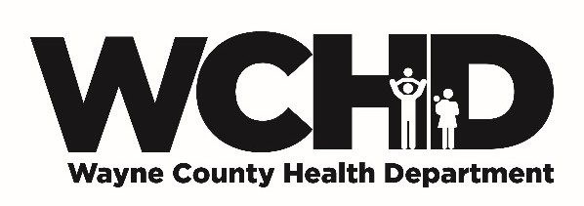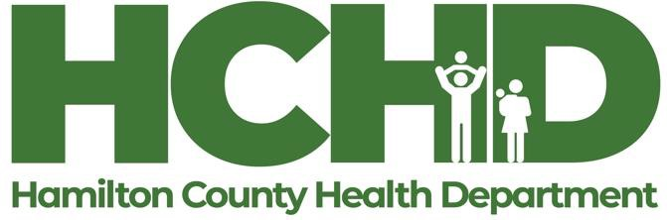

How to Obtain Your Certiﬁed Food Protection Manager certiﬁcate

Take an ANSI (American National Standards Institute) approved Certiﬁed Food Protection Managers (CFPM) course. The CFPM certiﬁcate is required to open a cottage food operation. Here are options to obtain this certiﬁcate:
- Olney Central College (www.iecc.edu/occ) in Olney oﬀers a regularly scheduled Sanitation & Safety Classes. The CFPM exam is taken at the end of the class. Call 618-395-7777 to register.
- Rend Lake College (www.rlc.edu) in Ina oﬀers a regularly scheduled day-long Sanitation & Safety Class. The CFPM exam is taken at the end of the class. Call 618-437-5321, Ext. 1714 to enroll.
- Southeastern Illinois College (www.sic.edu) in Harrisburg oﬀers a regularly scheduled day-long Sanitation & Safety Class, FOS 112. Call 618-252-5400 x4120 to register.
- ServSafe (www.servsafe.com/ServSafe-Manager) oﬀers an online CFPM course and online exam proctoring.
- The Corporate Training Center (www.ctcfoodsanitation.com/online-classes) holds regular CFPM courses in Mt. Vernon and Eﬃngham. They also oﬀer the course and exam proctoring online. Call 800-705-8204.
- SafeFood101 offers a monthly Certified Food Protection class at the Bonnie Café at 100 Aviation Drive at Mt. Vernon airport. Go to www.safefood101.com or call 618-406-4077 to register.
- StateFoodSafety offers online Certified Food Protection Managers classes at https://www.statefoodsafety.com/food-safety-manager-certification/illinois/all-other-counties.
- 360Training offers online Certified Food Protection Managers classes at 360Training Food Safety Manager training.
- AAA Food Handler has online Certified Food Protection Managers classes at https://aaafoodhandler.com/food-manager-certification/.

